

**Year 11 ATAR ECONOMICS – 2020**

**COURSE OUTLINE & ASSESSMENT SCHEDULE**

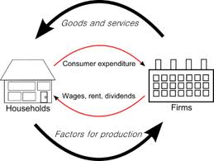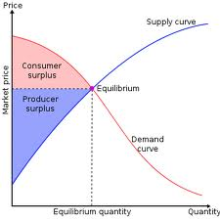

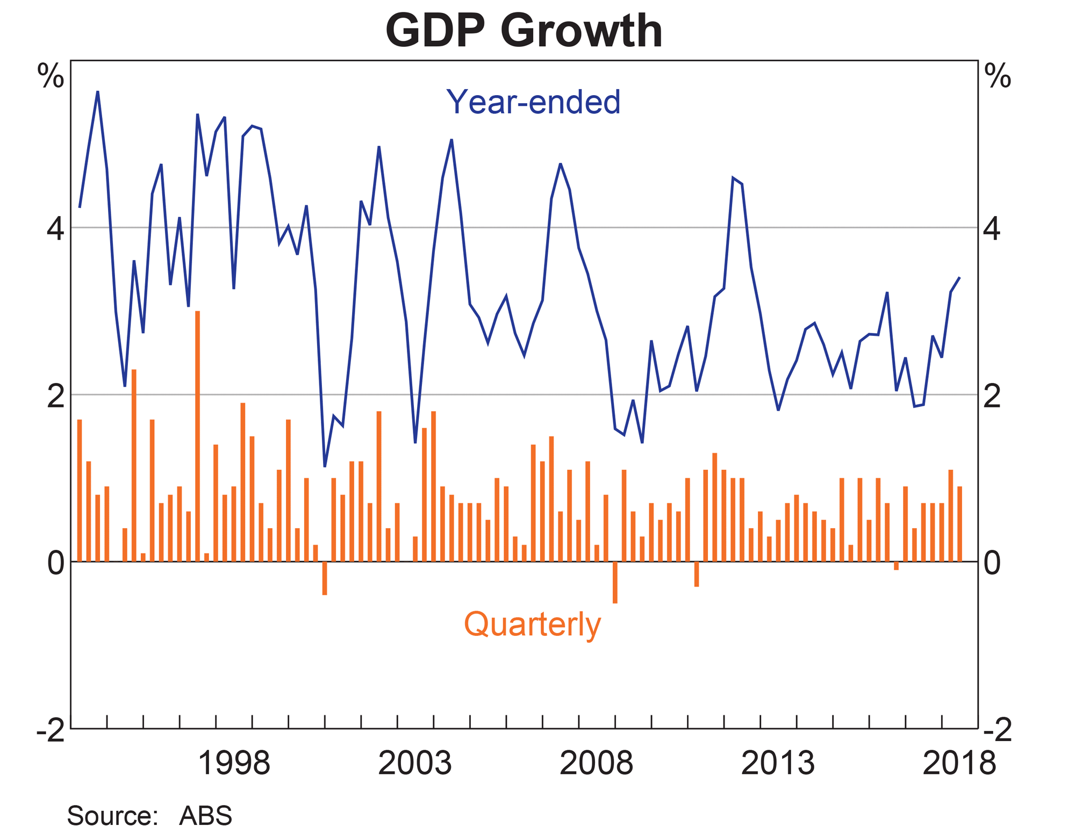

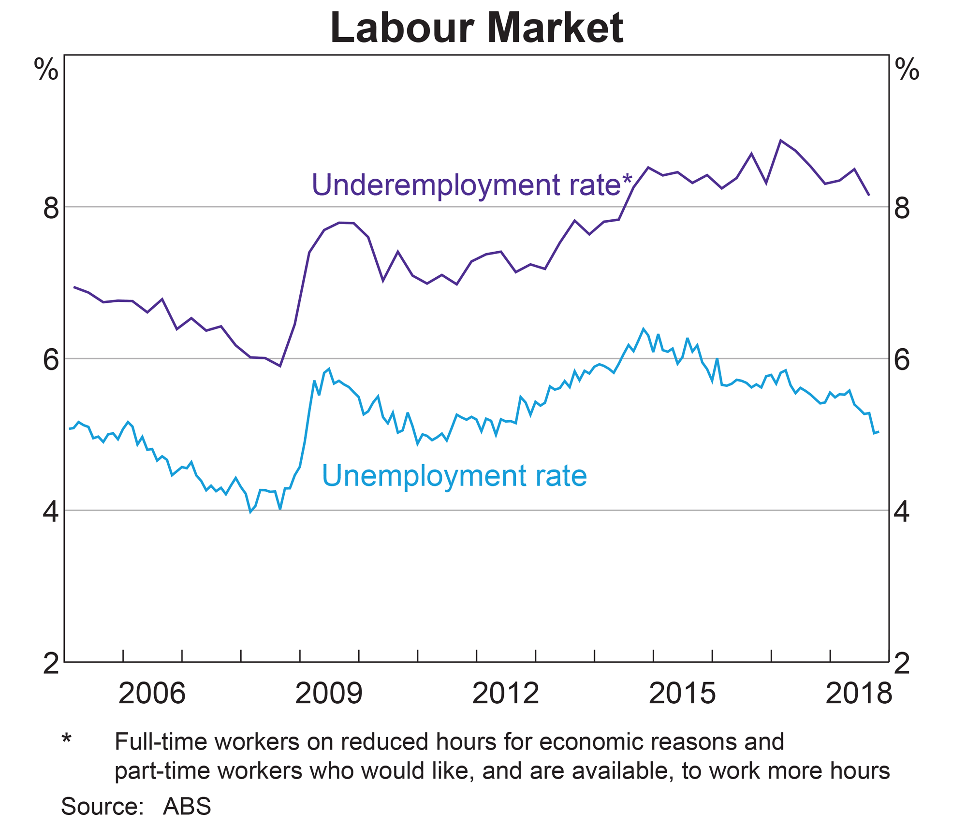

**Assessment Outline: Economics Units 1 & 2 – Times of Assessment may vary with notice**

|  |  |  |  |  |  |  |  |  |
| --- | --- | --- | --- | --- | --- | --- | --- | --- |
| **Unit** | **When** | **Assessment Type** | **Assessment Tasks / Content** | **Raw Mark** | **Task Weighting**  **%** | **Outcome 1 Economic Inquiry** | **Outcome 2 Operation of the Economy** | **Outcome 3 Economic Policy and Action** |
| 1 | T1 Wk 4 | Data Interpretation | Markets, Supply and Demand Analysis | 24 | 10 | √ | √ |  |
| 1 | T1 Wk 8 | Extended Answer | Elasticity, Efficiency and Equity | 20 | 10 | √ | √ | √ |
| 1 | T2 Wk 2 | Extended Answer | Research Assessment (Market failure) | 20 | 10 | √ | √ | √ |
| 1 | T2 Wk 5/6 | EXAM | All of unit 1 | 100 | 10 | √ | √ | √ |
| 2 | T2 Wk 8 | Data Interpretation | Macroeconomic Activity | 24 | 10 | √ | √ | √ |
| 2 | T3 Wk 3 | Extended Answer | Macroeconomic Concepts and Issues | 20 | 10 | √ | √ | √ |
| 2 | T4 Wk 7 | Data Interpretation | Macroeconomic Concepts and Issues | 24 | 10 | √ | √ | √ |
| 2 | T4 Wk 1 | Extended Answer | Researched Assessment – State of the Economy | 20 | 10 | √ | √ | √ |
| 1&2 | T4 Wk 4/5 | EXAM | Units 1 & 2 | 100 | 20 | √ | √ | √ |
|  | |  | **TOTAL** |  | **100%** |  | | |

**Schools Curriculum and Standards Authority:**

Data Interpretation 30%

Extended Answer 40%

Exam: 30%

**COURSE OUTLINE - YEAR 11 2012 Unit 1 – Economic Knowledge**

|  |  |  |  |  |
| --- | --- | --- | --- | --- |
| **WEEKS** | **PROGRAM** | **EXTENDED DETAIL** | **Skills /**  **General Capabilities** | **ASSESSMENT** |
| **1 & 2**  **T1** | Markets, Demand, Supply and Equilibrium | * the characteristics of a market economy * the distinction between product and factor markets * the law of demand * the relationship between individual and market demand schedules and curves * factors affecting demand * price * income * population * tastes and preferences * prices of substitutes and complements * expected future prices * the effect of changes in price on quantity demanded i.e. expansion or contraction of demand * the effect of changes in non-price factors on quantity demanded i.e. increase or decrease in demand * the law of supply * the relationship between individual and market supply schedules and curves factors affecting supply * price * costs of production * factors of production * expected future prices * number of suppliers * technology * the effect of changes in price on quantity supplied i.e. expansion or contraction of supply * the effect of changes in non-price factors on quantity supplied i.e. increase or decrease in supply | *Study Skill: Mind-mapping*  Literacy  Note Taking  Numeracy  Data Interpretation  Graphical Interpretation |  |
| **WEEKS** | **PROGRAM** | **EXTENDED DETAIL** | **Skills /**  **General Capabilities** | **ASSESSMENT** |
|  |  | * the concept of market equilibrium * the effect of changes in demand and supply on market equilibrium * the concepts of market clearing, shortages and surpluses * how the price mechanism clears market surpluses and shortages |  |  |
| **3 & 4**  **T1** | **Elasticity** | * the concept, and measurement, of price elasticity of demand * determinants of price elasticity of demand * the distinction between goods that are price elastic and price inelastic in demand * the link between price elasticity of demand and total revenue * the concept, and measurement, of income elasticity of demand * the behaviour of normal goods and inferior goods in response to changes in income * the concept of cross elasticity of demand * the significance of substitute and complementary goods in relation to price, income and cross elasticity of demand * the concept of price elasticity of supply * the distinction between goods that are price elastic and price inelastic in supply * determinants of price elasticity of supply * the significance of price and income elasticity for consumers, business and government | Numeracy  Data Interpretation  Critical & Creative Thinking  Graphical Interpretation | Assessment 1  Data Interpretation  10%  Week 4 |
| **5 & 6**  **T1** | **Efficiency & Equity** | * the concept of efficiency * the benefits to consumers as market participants, applying marginal benefit and consumer surplus * the benefits to producers as market participants, applying marginal cost and producer surplus * the efficiency of market equilibrium i.e. maximising total surplus * the concept of equity (fairness) * the relationship between equity and efficiency * policy options to promote equity * the effects of price celings and price floors on total surplus | Numeracy  Data Interpretation  Critical & Creative Thinking  Graphical Interpretation  *Study Skill: Time Management (Research Essay)* |  |
| **WEEKS** | **PROGRAM** | **EXTENDED DETAIL** | **Skills /**  **General Capabilities** | **ASSESSMENT** |
| **7 & 8**  **T1** | **Public Goods, Common Resources and Externalities** | * the concept of market failure * the distinction between public goods and common resources * why public goods suffer from the free rider effect * why common resources suffer from the tragedy of the commons * policy options to reduce market failure associated with public goods and common resources * the distinction between positive and negative externalities * how an externality can influence market efficiency i.e. a deadweight loss | Numeracy  Data Interpretation  Critical & Creative Thinking  Graphical Interpretation | Assessment 2  Extended Answer  10%  Week 8 |
| **9**  **T1** | **Market Power** | * the concept of market power * the distinction between perfect and imperfect markets * barriers to entry in a market * how market power can influence market efficiency i.e. a deadweight loss * the role of the Australian Competition and Consumer Commission (ACCC) in ensuring market efficiency * policy options to influence market power, including regulation/deregulation and legislation | Ethical Understanding  Literacy |  |
| **10 & 11**  **T2 W1** | **Market failure and the Effects of Government Policies** | * how under and overproduction in a market can result in a deadweight loss * the effects of a tax on a market   the effects of a subsidy on a market |  |  |
| **12 - 14**  **T2 (W2-4)**  **15 - 16**  **T2 (W5&6)** | **Exam Preparation &**  **Exam Weeks** | Exam Preparation | *How to revise*  *Mindmapping*  *Time Management (Research Essay)* | Assessment 3  Research Essay  10%  Term 2 Week 2 |

**COURSE OUTLINE - YEAR 11 2020 – Unit 2**

|  |  |  |  |  |
| --- | --- | --- | --- | --- |
| **WEEKS** | **PROGRAM** | **EXTENDED DETAIL** | **Skills /**  **General Capabilities** | **ASSESSMENT** |
| **17**  **(T2 W7 )** | **Macroeconomic Activity**  **Circular Flow of Income**  **&**  **Business Trade Cycle** | * the concept of macroeconomics and its relevance * the distinction between macroeconomics and microeconomics * revise the concept of the circular flow of income * the concepts of total spending, total output and total income and the relationship between them * the concepts of equilibrium, leakages and injections in the circular flow of income * the effect of changes in leakages and injections on the level of equilibrium in the circular flow of income model * the concept of the business cycle * the phases of the business cycle, and the characteristics of each phase * indicators of economic activity * leading indicators, including share prices, building loan approvals, new employment vacancies, business and consumer confidence, and stock/inventory levels * coincident indicators, including retail sales, and new car registrations * lagging indicators, including unemployment rates/levels and inflation rate | Numeracy  Data Interpretation  Critical & Creative Thinking  Graphical Interpretation |  |
| **18**  **(T2 W8)** | **Aggregate Expenditure** | * the components of aggregate expenditure * consumption * investment * government spending * net exports   factors affecting each of the components of aggregate expenditure | Numeracy  Data Interpretation  Critical & Creative Thinking  Graphical Interpretation | UNIT 2  Assessment 4  Data Interpretation  10%  Term 2 Week 8 |
| **WEEKS** | **PROGRAM** | **EXTENDED DETAIL** | **Skills /**  **General Capabilities** | **ASSESSMENT** |
| **19**  **(T2 W9)** | **Macroeconomic performance and The Economic Objectives fo the Australian Government** | * trends in, and influences on, Australia’s recent (the last ten years) economic performance using a range of economic indicators, including inflation, unemployment, economic growth and the current account balance * the impact of recent (the last ten years) domestic and international events on the performance of the Australian economy * the economic objectives of the Australian Government * sustainable economic growth * low unemployment (full employment) * low inflation (price stability) * a more equitable distribution of income * the efficient allocation of resources | Synthesising Information |  |
| **20**  **(T2 Week 10 )** | Economic Growth | * the concept, and measurement, of economic growth * the distinction between nominal gross domestic product (GDP), real GDP, and real GDP per capita * GDP as a measure of economic growth * determinants of economic growth * the costs and benefits of economic growth | Numeracy  Data Interpretation  Critical & Creative Thinking  Graphical Interpretation |  |
| **21**  **(T3 W1)** | **Inflation** | * the concept, and measurement, of inflation * the distinction between headline and underlying inflation * the costs of inflation and the benefits of low inflation * types of inflation * demand pull * cost push | Numeracy  Data Interpretation  Critical & Creative Thinking  Graphical Interpretation |  |
| **22**  **(T3 W2)** | **Unemployment** | * the concepts of unemployment, full employment, the natural rate of unemployment, the participation rate and underemployment * the measurement of unemployment * types and causes of unemployment, including cyclical, structural and frictional * the effects of unemployment * the implications of full employment for the economy * the possible short-term trade-off between unemployment and inflatio | Data Interpretation  Critical & Creative Thinking  Ethical Understanding |  |
| **WEEKS** | **PROGRAM** | **EXTENDED DETAIL** | **Skills /**  **General Capabilities** | **ASSESSMENT** |
| **23**  **(T3 W3 )** | **Income Distribution** | * the concepts of income and wealth * how the Lorenz curve represents inequality in the distribution of income and wealth | Ethical Understanding | UNIT 2  Assessment 5  Extended Answer  10%  Term 3 Week 3 |
| **24 & 25**  **(T3 Week 4&5)** | **The Public Sector** | * the role of the government in a modified market economy * regulation of business enterprises * stabilising the business cycle * redistributing income through taxation and spending * the provision of goods and services * the size of the government sector in the Australian economy currently, over time, and relative to other economies * the size and composition of government revenue and spending in Australia at the Commonwealth, state and local government levels | Synthesising Information |  |
| **26**  **(T3 W 6 )** | **Taxation** | * the distinction between * direct/indirect taxation * progressive/regressive/proportional taxation * taxes on income/expenditure * types of Commonwealth taxes, including personal and income tax, goods and services tax, company tax, capital gains tax, fringe benefits tax, mineral resources rent tax, carbon tax and excise duty * the concepts of equity, efficiency and simplicity in the context of Australia’s taxation system | Numeracy  Data Interpretation  Critical & Creative Thinking  Graphical Interpretation  Ethical Understanding |  |
| **27 & 28**  **(T3 W 7&8)** | **Balance of Payments** | * composition and direction of Australia’s trade * the concept of the balance of payments * the general structure of the current account, and the capital and financial account * the distinction between the current account and the capital and financial account * the relationship between the current account and the capital and financial account | Numeracy  Data Interpretation  Critical & Creative Thinking  Graphical Interpretation | UNIT 2  Assessment 6  Data interpretation 7.5%  Term 3 Week 7 |
| **WEEKS** | **PROGRAM** | **EXTENDED DETAIL** | **Skills /**  **General Capabilities** | **ASSESSMENT** |
| **29**  **(T3 W9)** | **REVISION OF:** **Macroeconomic performance and The Economic Objectives fo the Australian Government** | * trends in, and influences on, Australia’s recent (the last ten years) economic performance using a range of economic indicators, including inflation, unemployment, economic growth and the current account balance * the impact of recent (the last ten years) domestic and international events on the performance of the Australian economy * the economic objectives of the Australian Government * sustainable economic growth * low unemployment (full employment) * low inflation (price stability) * a more equitable distribution of income * the efficient allocation of resources | Synthesising Information |  |
| **30&31**  **(T3 W10)**  **(T4 W1)** |  | * Preparation for researched extended answer. | Research  *Study Skill: Time Management* | UNIT 2  Assessment 8  Research Extended Answer  10%  Term 4 Week 1 |
| **32 & 33**  **(T4 W 2&3 )**    **34&35**  **(T4 W 4&5 )** | Exam Preparation  **Exams** | Exam Preparation  Assessment Free Week (Week 2) | *How to revise*  *Mindmapping*  *Time Management*  *Graphical Interpretation* |  |